Evidence for Prototype (Screenshots)

Version 1
In the previous session, we created the storyboard. In this session, we are developing Prototype Version 1, which includes a welcome screen, lives system, score system, instructions, and game levels. Below, we have attached a screenshot of Prototype Version 1.
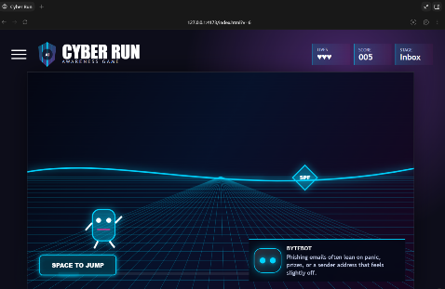
Figure 1 First screen of our prototype v1 including game title, live score, level of the game & the instruction.
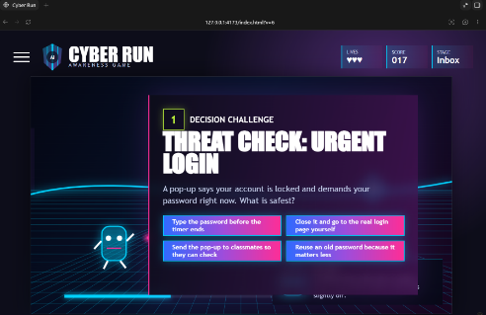
Figure 2 First challenge for the player including the options or choices

Version 2
In our version 2, We improved our designs, instruction with the new character (BYTEBOT) and also feedback with clear information.
Figure 3Updated prototypes of first screen as V2
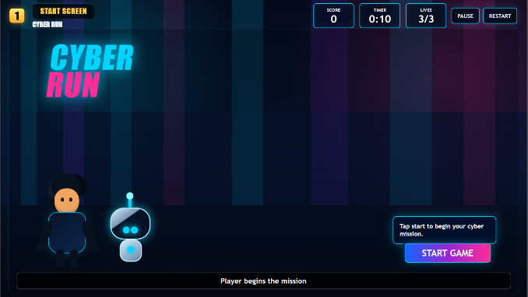
Figure 4 Updated prototype which includes instructions and information
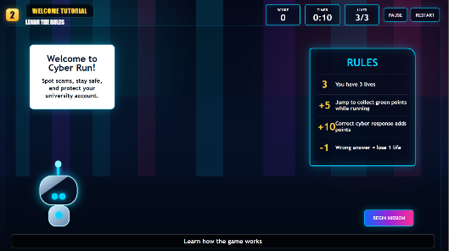
Figure 5 The challenge for the player
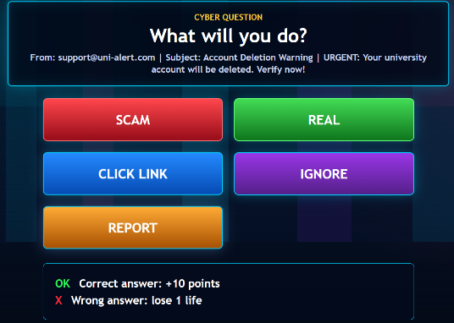

Figure 6 feedback with points for correct answers
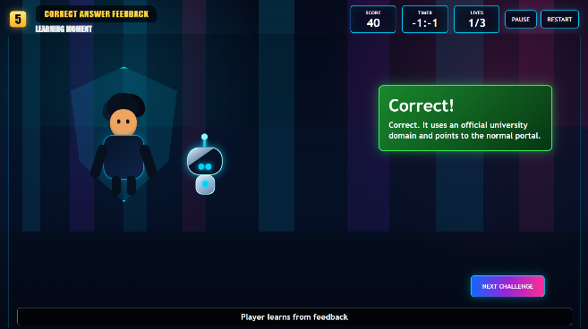
Figure 7 feedback for wrong answers
